Project 3 - Pizza Sale

1) Write an SQL query to calculate the total revenue generated from all pizza sales.

Select ROUND(SUM(total_price),2) AS total_revenue
FROM pizza_sale

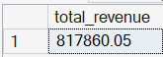

2) Write an SQL query to find the average order value of all customer orders.

SELECT ROUND(SUM( total_price)/ COUNT ( DISTINCT order_id),2) AS avg_order_value
FROM pizza_sale

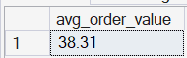

3) Write an SQL query to calculate the total number of pizzas sold.

SELECT SUM(quantity) AS total_pizza_sold
FROM pizza_sale

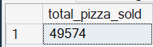

4) Write an SQL query to determine the total number of orders placed.

SELECT COUNT(DISTINCT order_id) AS total_order_placed
FROM pizza_sale

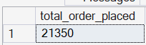

5) Write an SQL query to calculate the average number of pizzas sold per order.

SELECT ROUND(SUM(quantity)/
COUNT(DISTINCT order_id),2) AS avg_pizza_per_order
FROM pizza_sale

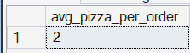
6) Write an SQL query to analyze the daily trend of total orders, showing the number of orders placed each day.

SELECT order_date,
COUNT(DISTINCT Order_id) AS total_orders
FROM Pizza_sale
GROUP BY Order_date
ORDER BY Order_date

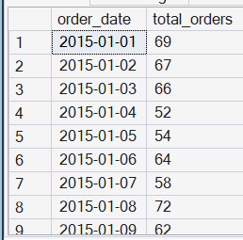

--ANOTHER WAY

SELECT DATENAME(DW, Order_date) AS order_day, COUNT(DISTINCT order_id) AS total_orders
FROM pizza_sale
GROUP BY DATENAME(DW, order_date)

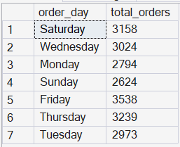

7) Write an SQL query to analyze the hourly trend of orders, showing the number of orders placed during each hour of the day.

SELECT Order_time,
COUNT(DISTINCT order_id) AS Total_orders
FROM pizza_sale
GROUP BY order_time
ORDER BY Order_time

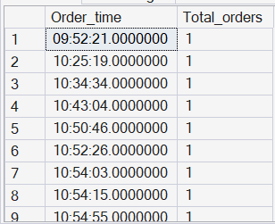

8) Write an SQL query to calculate the percentage contribution of sales by each pizza category.

SELECT pizza_category,
ROUND(SUM(Total_price)*100/
(SELECT SUM(Total_price)FROM pizza_sale),2) AS Sales_percentage
FROM Pizza_sale
GROUP BY pizza_category
ORDER BY Sales_percentage DESC

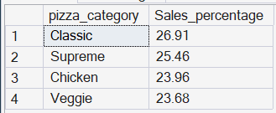

9) Write an SQL query to calculate the percentage contribution of sales by each pizza category.

SELECT pizza_size,
ROUND(SUM(total_price)*100/
(SELECT SUM(total_price) FROM pizza_sale),2) AS sales_percentage
FROM pizza_sale
GROUP BY pizza_size
ORDER BY sales_percentage DESC

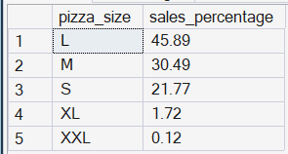

10) The daily trends according to each date

SELECT TOP 5
order_date, COUNT(DISTINCT order_id) AS total_order
FROM pizza_sale
GROUP BY order_date
ORDER BY order_date

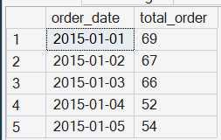

11) The daily trends according to each day

SELECT DATENAME (DW ,order_date) AS day_name, COUNT (DISTINCT order_id) AS total_order
FROM pizza_sale
GROUP BY DATENAME (DW ,order_date)
ORDER BY DATENAME (DW ,order_date)

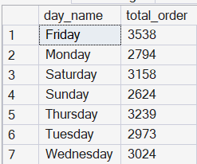

12) hourly trends of orders, showing no. of orders placed during each hour of the day

SELECT DATENAME( HOUR , order_time) AS Hourly_order, COUNT (DISTINCT order_id) AS total_order
FROM pizza_sale
GROUP BY DATENAME( HOUR , order_time)
ORDER BY DATENAME( HOUR , order_time)



